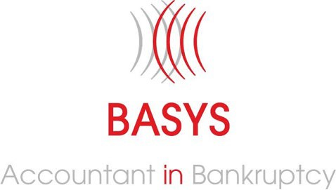

USER GUIDE

Adjudication and Supervision

Contents
1. Introduction 3
2. Task Lists 4
3. Notifications 5
4. Case Search 8
5. Insolvency Case 10
2. Case DCO 15
3. Documents 20
4. Direction Application 21
5. General Application 24
6. Appeals 26
7. Discharge Details 29
8. Case Debts 34
9. Other Functionality 36
10. Contact Details 37

Introduction
This document has been produced to assist trustees to utilise the BASYS system. It provides an overview of the system and a bankruptcy case file. All legislative references in this document refer to the Bankruptcy (Scotland) Act 2016, (The Act).
Further information is also provided in relation to aspects of the administration of a case where the trustee can liaise with the Adjudication and Supervision Team via BASYS.
The team are responsible for:

Adjudication
- Recall of bankruptcy
- Replacement and removal of a trustee
- Contractual powers of a trustee
- Cure defects in procedure
- Set debtor contribution orders
- Issue directions following an application by a trustee
- Defer a debtor’s discharge

Supervision
- General supervision of bankruptcy trustees and commissioners
- Identify and investigate issues with trustee cases and take action where necessary
- Respond to written correspondence / complaints
- Interpret legislation and other guidance to provide support to internal and external stakeholders
- Discharge debtors
- Discharge trustees

Task Lists
Task Lists are shown on the Home Page and those shown will be dependent on an individual’s permissions.
This will allow access directly to a Case File to carry out specific tasks To view a Task List:-
  - Select Home
  - From the relevant from the Drop Down Menu
  - Select Relevant Task List
  - Click on the relevant case reference
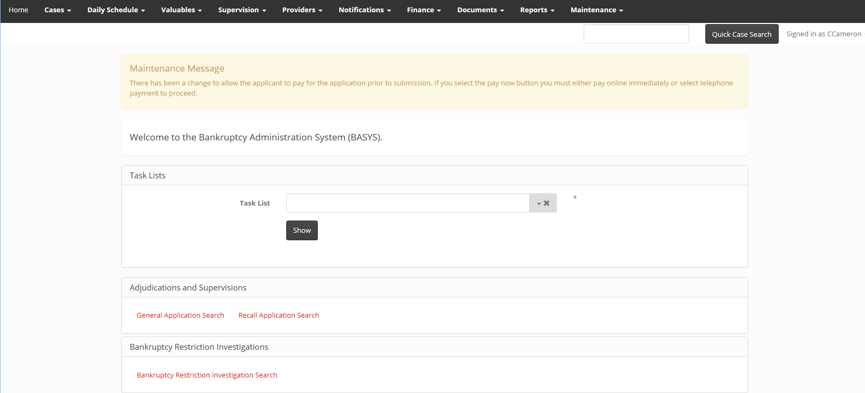

Notifications
Notifications can be used to make a party aware of information in relation to a case. A notification is created on an individual case but is recorded within the notifications tab of the case.
A Notification can be sent to:-
  - An individual (anyone within your organisation who has a log in)
  - An organisation (AiB)
  - Yourself
AiB would ask that trustee’s send Notifications to AiB:
  - When an account is submitted directly to BASYS
  - When a document is uploaded directly to BASYS
  - When a note is created on BASYS
  - When an application is submitted directly to BASYS (if instructed in this document)
  - To bring to the attention of AiB any relevant information AiB may send a notification to a trustee:-
  - To advise that a document is available for download
  - To bring to the attention of a trustee any relevant information

To Create a Notification
  - On the Case File scroll to the bottom of the page
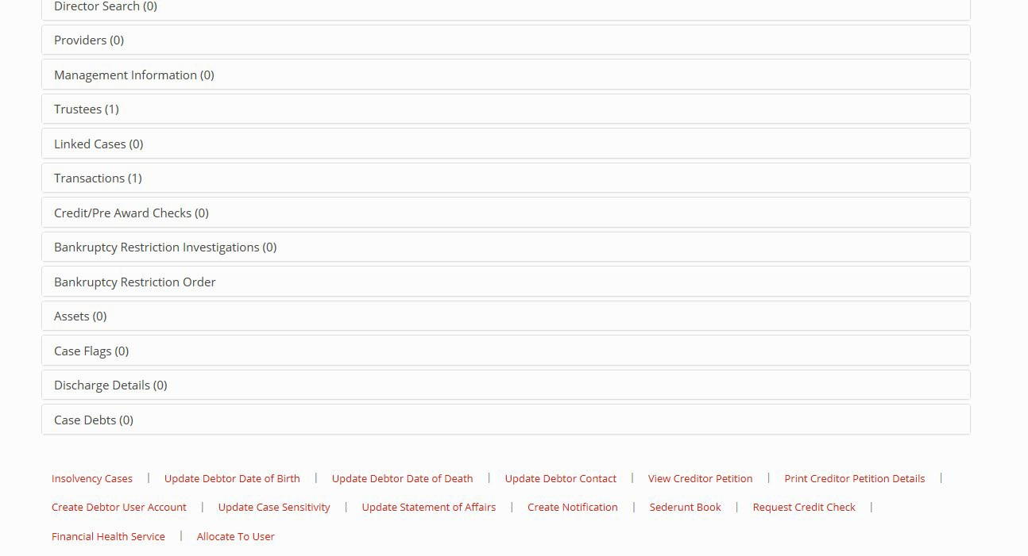
  - Click Create Notification
    - Recipient – Me / Another Individual User / An organisation
    - Recipient User / Organisation – choose from drop down menu / AiB
    - Subject - enter text
    - Message – enter text
    - Reminder Date – select relevant date
    - Click Create
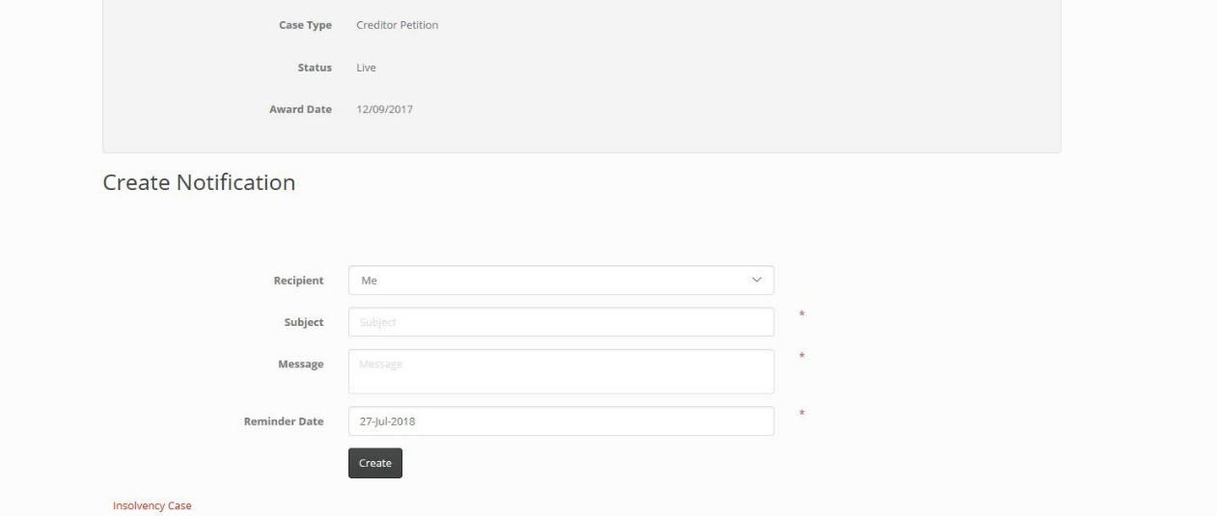

To Check Notifications
  - Select Notifications from the top toolbar
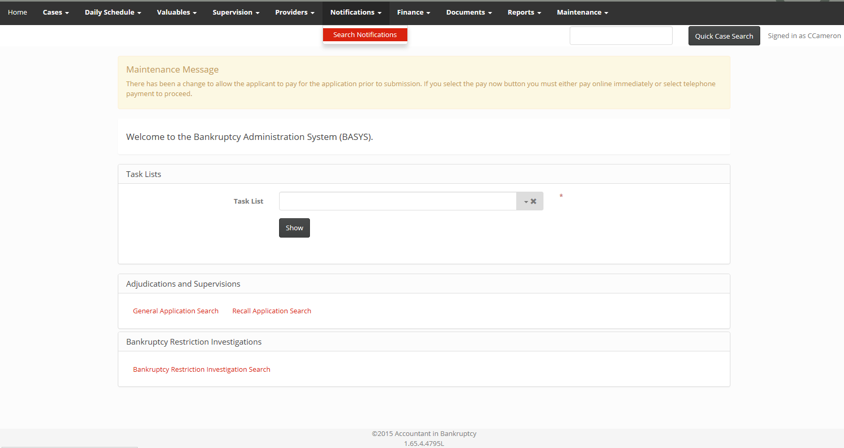
  - Status – Any / Pending / Dismissed
  - Show – Notifications Assigned to me / Notifications Assigned to my organisation / Notifications created by me / Notifications assigned to a specific user in my organisation (then select user)
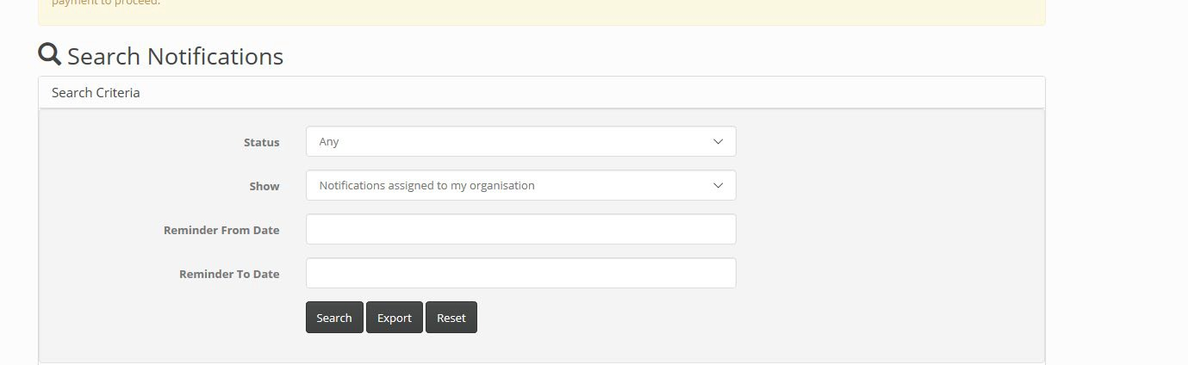
  - Click – Search
  - Select Subject
  - Information shown
    - Status – Pending / Dismissed
    - Subject – text entered
    - Message – text entered
    - Case Reference
    - Recipient User
    - Created On
    - Created By
    - Dismissed By
  - To action the Notification
    - Click Dismiss
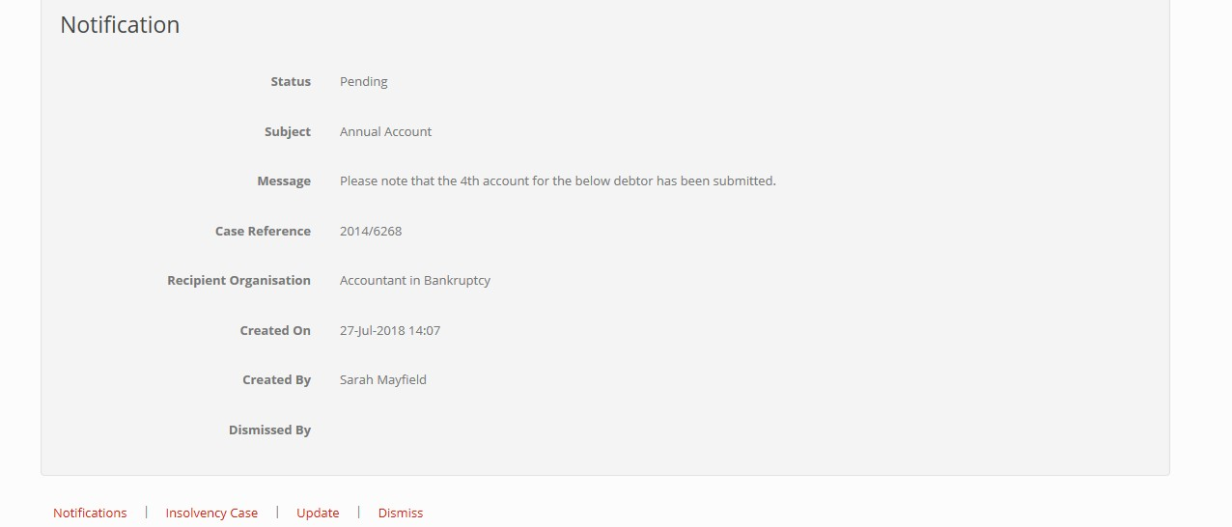
    - At the message ‘Are you sure you wish to dismiss this Notification?’ click Dismiss
    - Click Insolvency Case
    - Take any appropriate action

Case Search
There are 2 methods to search for a Case File, if not using the Task Lists.
  - If the Case Reference or Debtor Name is known enter the number, or name, into the Quick Search Box on the right hand side at the top of the page
  - If not known, select Cases from the top toolbar
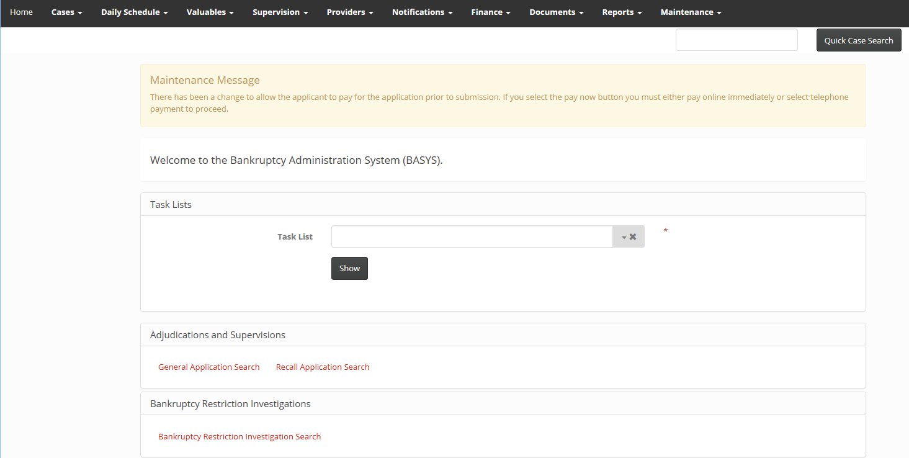
  - Select Personal Insolvency Cases
  - Enter any combination of the following within the Search Criteria
    - Reference Number
    - Debtor’s First Name *
    - Debtor’s Middle Names
    - Debtor’s Surname *
    - Debtor’s Date of Birth
    - Debtor’s Postcode *
    - Trustee’s Name
    - Bankruptcy Type
    - Any
    - Debtor Application for Full Administration
    - Creditor Petition
    - Creditor Petition Type
    - Any
    - None
    - Trust Deed Petition
    - Creditor Petition
    - Status
    - Money Adviser’s First Name
    - Money Adviser’s Surname
* most relevant criteria
  - Click Search
  - The list returned will only include cases for your firm
  - Select the correct case by clicking on the case reference number in red

Insolvency Case
This is the record of an individual case. Below is a summary of the information that can be found against each Tab.
For those Case Tabs highlighted in red further information on the use of this tab is provided at a later stage in this document.

Case Details
  - Reference Number
  - Case Type
  - Status
  - Case Owner
  - Case Administrator
  - Date of Sequestration
  - Date of Debtor Discharge
  - Hold Debtor Discharge
  - Reopened Date Debtor Details
  - Debtor’s Full Name
  - Date of birth
  - Address
  - Telephone number
  - Mobile Number
  - Email Address
  - Preferred Contact Method Debtor’s Other Details
  - Previous Addresses
  - Trading Addresses
  - Aliases
  - Owned Companies Case DCO
  - Details of any Debtor Contribution Orders and / or variations Inhibition Details
  - View date of registration of the inhibition (debtor applications only)
Recall Details
  - Date of recall (by court or AiB)
  - Recall Petition Received Date (court applications only)
  - Recall Petition Hearing Date (court applications only) Notifications
- All notifications that have been created from the case Documents
  - Insolvency Case Documents
    - All Sederunt Book documents
    - All other correspondence received from the trustee / debtor / creditors
  - Trustee Account Documents
    - All documents submitted and produced relating to the determination of accounts by AiB
Conversation
  - The purpose of this section is to allow communication between parties to be carried out directly via the case and recorded without the need to send emails or letters
Reviews
  - All review applications received for the case Directions
  - All Direction applications received for the case
  - Ability to create a Direction application General Applications
  - View all General / Recall applications received for the case
    - Name of Applicant
    - General Application Status (Draft / Submitted / Returned / Completed)
    - Submitted On – date
    - Opened On – date
    - Created On – date
    - Created By – name
    - Completed On – Date / time
    - Type – General / Recall

  - Ability to create a General application
  - Ability to create a Recall application Trustee Accounts
  - All accounts received for the case
    - Account Type (First / Subsequent / Scheme of Division / Final)
Appeals
  - Details of all appeals lodged at court
  - Ability to create/update an appeal
Trustee
  - History of trustee appointment
    - Trustee name
    - Trustee type
    - Date Appointed
    - Date Discharged
    - Current Trustee Yes / No Director Search
  - Debtor applications only
  - Any information obtained by AiB in relation to a director search at Companies House
Linked Cases
  - Details of linked cases
    - Spouse
    - Same address
    - Business relationship Transactions
  - Lists all transactions raised by AiB for a case
    - Code Category (Sequestration Income / Outlay / Fee / Payment / Bank Interest / Expense of Realisation / Service Request / Credit Note)
    - Transaction Code
    - Raised – date
    - Name – type of transaction (Initial Petition Fee / Audit Fee / Supervision of Sequestration – No Commissioner Elected)
    - Target Pick Code – info only
    - Target Name – name of person transaction raised against
    - Target Type – (Creditor / Trustee / Debtor)
    - Net Unit Amount
    - VAT Total Amount
    - Gross Total Amount
    - VAT Recoverable
    - Status (Pending / Authorised / Processed)
  - Where the transaction is shown as ‘Processed’ an invoice will have been issued
Bankruptcy Restriction Investigation
  - Details of Applications
  - Ability to create investigation application
  - Ability to see any investigation submitted
  - Ability to add notes or documentation
  - Status – submitted / open / rejected / returned / outcome Assets
- Create heritable asset
- Electronic submission of appendix L Discharge Details
  - Debtor Discharge Reports
  - Deferral of Debtor Discharge Reports Case Debts
  - Automatically populated from debtor applications
  - Ability to create / update / delete debts
  - Information shown
    - Id No
    - Type of debt
    - Creditor Name
    - Creditor Address
    - Reference Number
    - Date Debt Obtained
    - Amount Agreed(£)

Case DCO
A Debtor Contribution Order (DCO) is set by AiB at the time of award of a Debtor Application or after the award of a Creditor Petition, following the submission of a proposal by the trustee.

A DCO must be set for all cases, ie partnerships, entities, deceased debtors. Information shown on the DCO Tab:-
  - Effective From Date
  - End Date
  - Amount
  - Frequency
  - Reason for Change Creditor Petition – Proposal
  - Submitted to AiB on an Appendix O, setting out the amount the trustee is requesting the contribution to be fixed at, the date of first payment, and confirming
    - No more than 6 weeks has passed since the date of award
    - The Common Financial Tool (CFT) has been used to assess the debtor’s circumstances

    - The debtor’s relevant obligations have been taken into consideration
    - Any details of a third party who will make the payment
  - Trustee to provide copy of calculation of income and expenditure
    - Printed copy of summary from AiB Common Financial Tool (on website)
    - Printed copy of summary from any other Common Financial Tool
    - Evidence of breach of trigger figures
    - Explanation as to why any breach should be accepted
  - AiB staff may query
    - High rent payments
    - High utility payments
    - Anomalies – payment of mortgage and rent
    - Figures that exceed the trigger figures (if no explanation provided)
  - AiB staff will consider
    - Has the application been received within the relevant timescale
    - If not, the documentation will be returned and a Section 212 application will require to be made prior to the proposal being resubmitted and considered
    - Review all documentation held
    - Expenditure should be shown as actual not the trigger figure
- DCO amount to be amended by AiB
  - Email / letter will be issued to trustee’s office providing details of amendments to be made

  - The trustee will be given 7 days to respond to provide further information / evidence
- Issue of DCO document
  - Fix as requested or amended
  - Where amended the CFT will be used
  - Update BASYS
  - Issue the DCO to the debtor / the trustee / any third party named on the proposal
  - Cannot start less than 15 days from the date of the decision
  - Each of these parties has the right to request a review of the decision Variation of Payment Period
  - Section 91 – Payment period and intervals
  - Initial period will be for 48 months
  - Can be varied to a shorter or longer period
  - Shorter if the trustee realises sufficient assets to pay creditors in full plus interest and fees
  - Longer period if the debtor did not pay an amount required or is agreed by the debtor and trustee
  - A new DCO document should be drawn up
  - A copy of the new DCO must be uploaded to the case and a Notification sent to AiB
  - AiB will update the BASYS system.
Payment Break
  - Section 96
  - Period not exceeding 6 months

  - Debtor may apply if
    - Reduction of disposable income of at least 50%
    - Not previously applied for a payment break
  - Circumstances
    - Period of unemployment or change in employment
    - A period of leave from employment ie birth/adoption of a child or care of a dependent
    - Period of illness
    - Divorce or separation
    - Death of a person who, along with the debtor, cared for a dependent of the debtor
  - If granted the trustee must notify the debtor, any third party making the payment and AiB (by uploading a copy to BASYS)
  - If not granted the trustee must notify the debtor and provide an explanation and upload a copy to BASYS
  - All parties have the right to request a review
  - Upon completion of the payment break the DCO should be amended under section 95 of the Act
Variation and Removal
  - Section 95 - Variation and Removal of the DCO by the trustee
  - Variation can be made on an application by the debtor, by the trustee after a change in the debtor’s circumstances or when sending a debtor discharge report to AiB
  - Must use the CFT to assess the circumstances
  - Cannot take effect less than 15 days from the date of the decision
  - A new DCO document should be drawn up with the following:
    - New DCO Amount
    - Frequency
    - Effective From Date
    - Reason for Change – provide details
  - Trustee must notify the debtor, the creditors, any third party making the payment and AiB
  - The trustee must also upload a copy of the CFT and evidence of the change of circumstances or an explanation as to why the DCO is being brought to an end and send a Notification of upload
  - All parties have a right of review
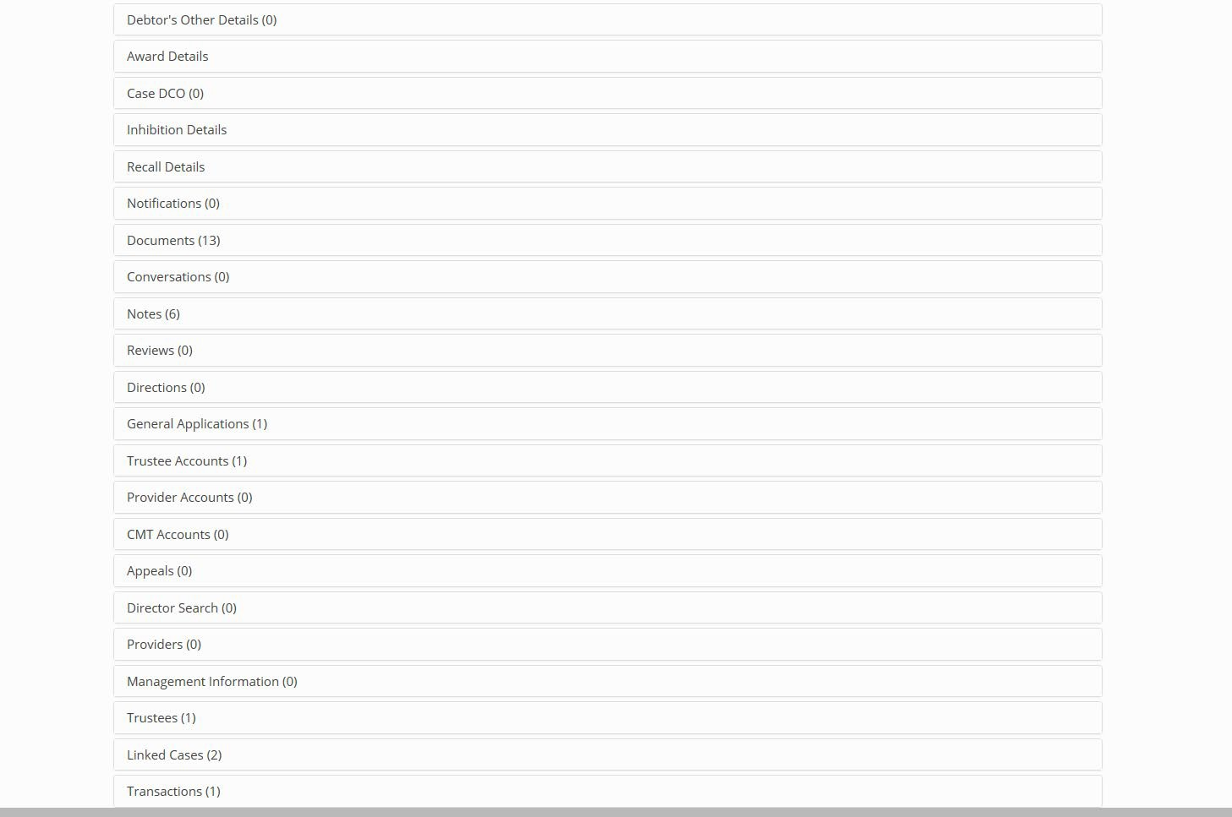

Documents
This section holds all general documents relating to a case.
To upload a document
  - Select Document Tab
  - Select Insolvency Case Document
  - Select Upload Document
  - Name – enter as much detail as possible
    - Statement of Affairs
    - Standard Questionnaire
    - Account Circular period ending xx/xx/xx
    - Appendix O
- Document Category – Case Workflow
- Document Type – Insolvency Case
- Include in Sederunt Book – Yes / No
- Is Aib only – tick if document is not to be placed in the Sederunt Book
- Upload Document – Click Browse, select document
- Click Upload Document
- Click Insolvency Case
- Scroll to bottom of the screen
- Create Notification
- Upon receipt the document will be checked and any required updates will be made (ie document category or type, not AiB only)
- Create notification to inform AiB of any documentation that has been uploaded to the case.

Direction Application
From 1 April 2015 if trustee wishes to apply for direction in a case this should be made to AiB under section 52 of the Act. This applies to all cases irrespective of date of award.
All documents relating to an application will be available in this section and not within the Documents Tab.

Create an Application
  - If the Case Reference is known enter the number into the Quick Search Box
  - If not known, select Cases from the top toolbar
  - Select Personal Insolvency Cases
  - Enter the case debtor’s details within the Search Criteria
  - Select the correct case by clicking on the case reference number in red
  - Scroll down the case and click on Directions
  - Click Create General Direction
- Enter
  - Applicant’s Name – trustee’s name
  - Search Postcode – enter the postcode of the applicant
  - Click Find Addresses
  - Matched Addresses – select the correct address from the drop down menu
  - The applicant craves the Accountant – enter a brief summary of direction sought
  - Statement of Facts – enter all details or type “ see attached document” as space is limited
  - Pleas in Law – enter all details listed or type “ see attached document”
  - Click Create
  - Status shown as Draft
  - Select Upload Document - Upload any required documents
    - Name – ‘Statement of Facts and Pleas in Law’
    - Category – Case Workflow
    - Type – Insolvency Case
    - Browse – find scanned document
    - Click – Upload Document
    - Click Direction
    - Repeat the above for any additional information using
    - Name – ‘Direction Application – Additional Information’
    - Click Submit
    - At the message ‘Are you sure you wish to submit this Direction’ click submit
    - Status will change to Submitted
  - Click Insolvency Case
  - Scroll to the bottom of the screen
  - Click Create Notification to inform AiB of upload

General Application
General applications can be made in the following circumstances:-

  - Section 31 recall of bankruptcy
  - Section 70 removal of a trustee
  - Section 159 annulment/variation of a BRO
  - Section 212 cure defect in procedure
The system has been developed to separate recall applications from all other applications. All documents relating to an application will be available within the general applications tab.
The application must be intimated to all interested parties. A list of the interested parties is shown at each individual section of the Act. AiB expect all creditors and the debtor to be notified, and a list of creditors to be provided when submitted the application.
Create an Application

- Scroll down the case and click on General Application

- Click Create General Application OR Recall Application
- Enter
  - Reason for Application – late submission of account / objection to trustee election/ Recall
  - Section of the Act Applied Under – section of 2016 Act
  - Name – enter name of trustee
  - Search Postcode – enter the postcode of office
  - Click Find Addresses
  - Matched Addresses – select the correct address from the drop down menu
  - Designation of Applicant – trustee
  - List of relevant parties notified of this application – enter all details listed
  - Date of Notification – enter date interested persons notified
  - Statement of Facts – enter all details listed or type “ see attached document” as space is limited
  - Pleas in Law – enter all details listed or type “ see attached document”
  - Click Create
  - Status shown as Draft
- Select Upload Document - Upload any required documents
  - Name – ‘Application under Section 212 – Statement of Facts and Pleas in Law’ Category – Case Workflow
  - Type – Insolvency Case
  - Browse – find scanned document
  - Click – Upload Document
  - Click General Application
  - Repeat the above for any additional information using
  - Name – ‘Application under Section 212 – Additional Information’
  - Click Submit
  - At the message ‘Are you sure you wish to submit this General Application’ click Submit
  - Status will change to Submitted

Appeals

  - Information available
    - Appeal Summary
    - Hearing Court
    - Hearing Date
    - Court Reference Number
    - Action Completed Date Create Appeal
  - Click Create Appeal
  - Summary – brief description of type of appeal (account determination / review decision by AiB)
  - Particulars – see attached document
  - Hearing Court – select from drop down menu
  - Hearing Date – select date
  - Court Reference number – see document (ie SQ)
  - Click Create
  - Select Add Appeal Document
    - Name – ‘Court Interlocutor’
    - Category – Case Workflow
    - Type – Insolvency Case
    - Is Aib only – tick
    - Browse – find scanned document
    - Click – Upload Document
  - Click Appeal
  - Click Insolvency Case
  - Scroll to the bottom of the screen
  - Click Create Notification
    - Recipient – An organisation
    - Recipient Organisation – AiB
    - Subject – Appeal lodged
    - Message – information uploaded to case
    - Reminder date – today
    - Click – Create To update an Appeal
  - Select relevant appeal summary in red
  - Click Update
  - Update
    - Appeal Outcome (Upheld / None / Not Upheld)
    - Action Complete – enter any relevant information (ie any actions taken as result of an upheld appeal)
  - Click Insolvency Case
  - Scroll to the bottom of the screen
  - Click Create Notification
    - Recipient – An organisation
    - Recipient Organisation – AiB
    - Subject – Appeal update
    - Message – information uploaded to case
    - Reminder date – today
    - Click – Create

Discharge Details
This section is separated into 4 sections:-
  - Debtor Discharge Reports
  - Deferral of Debtor Discharge Reports
  - Trustee Discharge
  - Re-open Case Application
These sections can only be accessed at the appropriate time in the administration of the case as follows:-
  - Debtor Discharge - 10 months after award
  - Deferral of Debtor Discharge – between 8 and 10 months after award
  - Trustee Discharge – after the final account has been determined
  - Re-open Case – after a trustee has been discharged Debtor Discharge
Applications should be made to AiB without delay 10 months after the award of bankruptcy. For creditor petitions this is the award date, not the date of bankruptcy.
The trustee submits an application to AiB and a copy of the report section must be sent to all creditors and the debtor. They should be advised that they have 28 days to make representation to AiB against the recommendation of the trustee.
The report must contain:-
- Details of the debtor’s conduct and the effect of this on the trustee’s ability to administer the case (ie they have co-operated and to what extent a trustee has been able to realise assets, obtain documentation)
- The extent of their co-operation with the DCO (any payments that have been missed, what has been the outcome of any review)
- The trustee’s recommendation

An application must be made for all cases, ie partnerships, entities, deceased debtors.
Create a Debtor Discharge Report
- Select the Home Page
- From the drop down menu select Debtor Discharge Reports Due
- Select the correct case by clicking on the case reference number in red
- Scroll down the case and click on Discharge Details
- Click Debtor Discharge Reports
- Click Create Debtor Discharge Report
- Enter
  - Applicant’s detail – enter name of trustee
  - Applicant’s address – enter the trustee’s address
    - Search Postcode – enter the postcode of the applicant
    - Click Find Addresses
    - Matched Addresses – select the correct address from the drop down menu
  - For and on behalf of AiB – leave blank
  - Recommend discharge –
    - Where the recommendation is to grant discharge – tick box (section 5 on the screen will now read “ I would recommend the debtor’s discharge is granted under section 137 of the Act”
    - Where the recommendation is not to grant discharge – leave blank (section 5 of the screen will now read “ I would recommend the debtor’s discharge is not granted”
  - Report – enter ‘see attached document’

  - Click Create
  - Status shown as Draft
- Select Upload Document - Upload the report and / or circular
  - Name – ‘Debtor Discharge Report’
  - Category – Debtor Discharge Report
  - Type – Debtor Discharge Report Supporting Evidence
  - Browse – locate document
  - Click – Upload Document
- Click Debtor Discharge Report Details
- Repeat the above to upload the circular
- Name – ‘Circular to debtor/creditors [date issued]’
- Repeat the above to upload the any additional documents
- Name – Trustee Report on Debtor Discharge – Additional Information’
- Click Update
- Scroll to the bottom of the screen
- Click Submit (the system will not allow you to submit the report if the relevant period has not yet expired)
- At the message ‘Are you sure you wish to submit this Recall Application’ click Submit
- Status will change to Submitted
Where discharge is not granted a further application must be made by the trustee. Discharge will be granted when the reasons for not granting discharge have been fulfilled. There is no timescale for this second report, but it must be made prior to any request for the trustee to be discharged.

Deferral of Debtor Discharge
Application must be made no earlier than 8 months and no later than 10 months from date of award.
The conditions are
- the debtor cannot be traced and the trustee has made reasonable enquiries to establish their whereabouts,
and
- The trustee is unable to carry out their duties in accordance with section 3 of the Act
The trustee submits a report to AiB on BASYS. The application must include a report providing evidence of what actions the trustee has taken to trace the debtor
A Form 10 is sent to all creditors and to the debtor’s last known address. The debtor and creditors have 14 days to make representation to AiB.

Create a Deferral of Application
- If the Case Reference is known enter the number into the Quick Search Box
- If not known, select Cases from the top toolbar
- Select Personal Insolvency Cases
- Enter the case debtor’s details within the Search Criteria
- Select the correct case by clicking on the case reference number in red
- Scroll down the case and click on Discharge
- Click on Deferral of Debtor Discharge Reports
- Enter
  - Applicant’s Title – enter Mr/Mrs/Ms (as applicable)
  - Applicant’s First Name - enter trustee’s first name
  - Applicant’s Surname – enter the trustee’s surname
  - Search Postcode – enter the postcode of the address given on the form
  - Click Find Addresses
  - Matched Addresses – select the correct address from the drop down menu
  - Evidence In Support – enter ‘see attached Report’
  - Click Create
  - Status shown as Draft
  - Select Upload Document - Upload any required documents
    - Name – ‘Description of Document’

    - Category – Case Workflow
    - Is Aib Only – tick box
    - Type – Insolvency Case
    - Browse – find scanned document
    - Click – Upload Document
- Click Debtor Discharge Report
- Repeat the above for any additional documents
- Click Submit
- At the message ‘Are you sure you wish to submit this Deferral of Debtor Discharge Report‘ click Submit
- Status will change to Submitted

Case Debts
This section holds details of all debts in a case. It will be used by AiB to draw information to issue letters to creditors.
It is requested that for Debtor Application cases the trustee update this section with any changes if debts are identified or sold/assigned during the administration of a case.
Alternatively, upon making any application to AiB the trustee must provide an up to date list of all creditors and reference numbers with each application.
Create Case Debts
  - Select the Case Debts Tab
  - Click Create Case Debt
  - Type of debt – egg credit card/loan/overdraft
  - Organisation Selector – drop down menu – select relevant creditor
  - If creditor not on drop down menu
  - Enter details of Creditor Organisation Name
  - Search Postcode – enter details
  - Click Find Addresses
  - Select address from Matched Addresses drop down menu
  - Enter Reference Number (if known – if not UNKNOWN)
  - Date Debt Obtained – enter date
  - Agreed amount – enter 0.00
  - Claim Amount – enter amount
  - Click Create
Update Case Debts
  - Select the Case Debts Tab
  - At the relevant entry click Update
  - Update any relevant entries
  - Click Update
Delete Case Debts
  - Select the Case Debts Tab
  - At the relevant entry click Delete
  - Click Delete
All deleted debts are shown in deleted debts section.

Other Functionality
Insolvency Cases
This will open an advanced Case Search. View Debtor Application / Creditor Petition
  - Debtor Application
  - Creditor Petition
    - Petitioning Solicitor
    - Debtor
    - Previous Address
    - Business
    - Nominated Trustee
    - Court & Dates
    - Petitioners
    - Debts
    - Employment Details & Owned Companies Print Debtor Application / Creditor Petition Details
  - Ability to print details Update Debtor Contact
  - Ability to update any relevant details Create Notification
  - Ability to create Notification Sederunt Book
  - All documents uploaded into any section of BASYS that has been tagged as a Sederunt Book documents will show in this section
  - CFT Guidance
- Direct link to guidance document Debtor Application Guidance
- Direct Link to guidance document

Contact Details
Adjudication and Supervision Team
  - 0300 200 2916
  - AST@aib.gov.uk
  - Team Leader – Claire Cameron 0300 200 2757

