Scottish Diligence Statistics 2022-23
Table of Contents
Main Points 2
About this release 3
Diligences executed by warrant procedures 3
Diligences executed under Summary Warrant and by diligence processes 5
Diligences executed under Non-Summary Warrant by diligence processes 6
Diligences executed by Sheriffdom 7
Charge for Payment 8
Charge for Payment by Sheriffdom 10
Inhibition 11
Guide to diligence processes 11
Background information 15
An Official Statistics publication for Scotland 20

Released: 13 September 2023
Next update: 11 September 2024
Authors: Catherine McAuley and Lucy Horner
Contact details: AiB Statistics Team
Data used in this release: Scottish Diligence 2022-23
Media enquiries: AiB Communications team
Twitter: AiB_updates; ScotStat
Official Statistics Label: Official Statistics
Note: These statistics are for the period 01 April 2022 to 31 March 2023 (inclusive), therefore the data relates to diligence during the impacts of the COVID-19 pandemic in Scotland.
We want your feedback: All feedback on these statistics is welcome. This can be done either by completing a short online feedback form or by email.

Main Points
Total diligences executed, for all warrant procedures and diligence processes, decreased by 6.7% from 282,495 in 2021-22 to 263,570 in 2022-23. When compared to pre-pandemic levels in 2019-20, total diligences executed, for all warrant procedures and diligence processes, decreased by 9.6%.
The majority (91.2%) of total diligences executed in 2022-23 were served under the Summary Warrant procedure in respect of council tax debts. Diligences executed in respect of council tax debts decreased by 5.8% when compared with the previous financial year and decreased by 0.2% when compared with prior to the pandemic (2019-20).
For the Non-Summary Warrant procedure, diligences executed decreased by 19.5% to 17,930 in 2022-23. This 2022-23 level is still below levels seen prior to the pandemic.
The number of Charge for Payments decreased from 277,545 in 2021-22 to 270,120 in 2022-23, a decrease of 2.7%. The majority (79.2%) were served in respect of council tax debts.

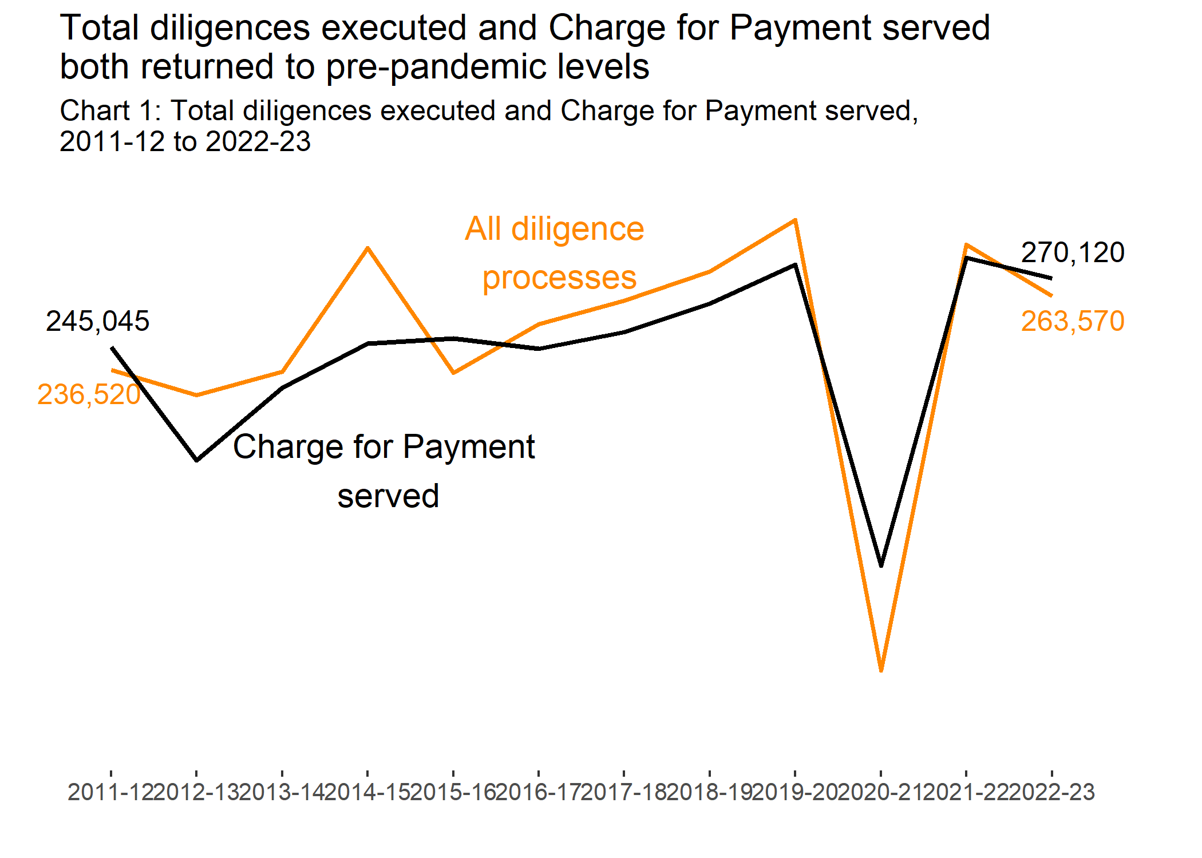
Chart 1 shows the total number of diligences executed and the number of Charge for Payments Served between 2011-12 and 2022-23. This chart shows that total diligences executed, and Charge for Payment served both returned to pre-pandemic levels.

About this release

How are diligence statistics collected?
Officers of the court need to collate and return information to the Lord Advocate. The Lord Advocate may publish the information submitted by the officers of the court. The published information does not include personal details.
Following an agreement in September 2009, AiB handles collecting and publishing diligence statistics. Scottish Government’s Justice Analytical Service division were responsible before. The published statistics are subject to disclosure control. See Section 84 of the Debtors (Scotland) Act 1987 and Code of Practice for Official Statistics for more information.
The Society of Messenger-at-Arms and Sheriff Officers (SMASO) directory identifies officers of court. In 2022-23, all members submitted data collection returns. Thank you to all officers of court for returning diligence data used in the publication.
It is important to note this publication does not include criminal court fines. The Fines Enforcement Officers are responsible for pursuing payment of fines. The Scottish Courts and Tribunals Service collates these statistics. These are available at SCTS Official Published Statistics.

Diligences executed by warrant procedures
The total number of diligences carried out in 2022-23 was 263,570, a 6.7% decrease on the previous year. When compared with prior to the pandemic (2019-20), total diligences carried out decreased by 9.6%.
There are two warrant procedures used to pursue diligence: Summary Warrant and Non-Summary Warrant. Summary Warrant is granted in respect of central and local government debts, and Non-Summary Warrant for all other types of debt. The Summary Warrant procedure is further disaggregated to show those granted for the enforcement of council tax.
Further comparisons on warrant procedures shown in Table 1 below.

Warrant procedure | 2018-19 | 2019-20 | 2020-21 | 2021-22 | 2022-23 | Annual Change
Summary Warrant (council tax) | 239,535 | 240,890 | 114,545 | 255,395 | 240,490 | -5.8%
Other Summary Warrant | 6,315 | 5,600 | 1,390 | 4,820 | 5,150 | 6.8%
Non-Summary Warrant | 26,840 | 45,040 | 10,730 | 22,280 | 17,930 | -19.5%
Total diligences executed | 272,690 | 291,535 | 126,665 | 282,495 | 263,570 | -6.7%
Source: Officers of court

The majority (91.2%) of total diligences executed in 2022-23 were served under the Summary Warrant procedure in respect of council tax debts. Diligences executed in respect of council tax debts decreased by 5.8% compared with 2021-22. Since 2011-12, diligences executed in respect of council tax debts have increased by 28.4%.
Other Summary Warrant includes other types of local and central government taxes, duties and levies. Diligences executed under this warrant procedure increased by 6.8% in 2022-23 compared to the previous year. This 2022-23 level is similar to levels seen prior to the pandemic.
For the Non-Summary Warrant procedure, diligences executed decreased by 19.5% from 22,280 in 2021-22 to 17,930 in 2022-23.
Chart 2 shows that the Non-Summary Warrant procedure has been subject to change in recent years. This is due to legislative changes and customer requirements of officers of court.

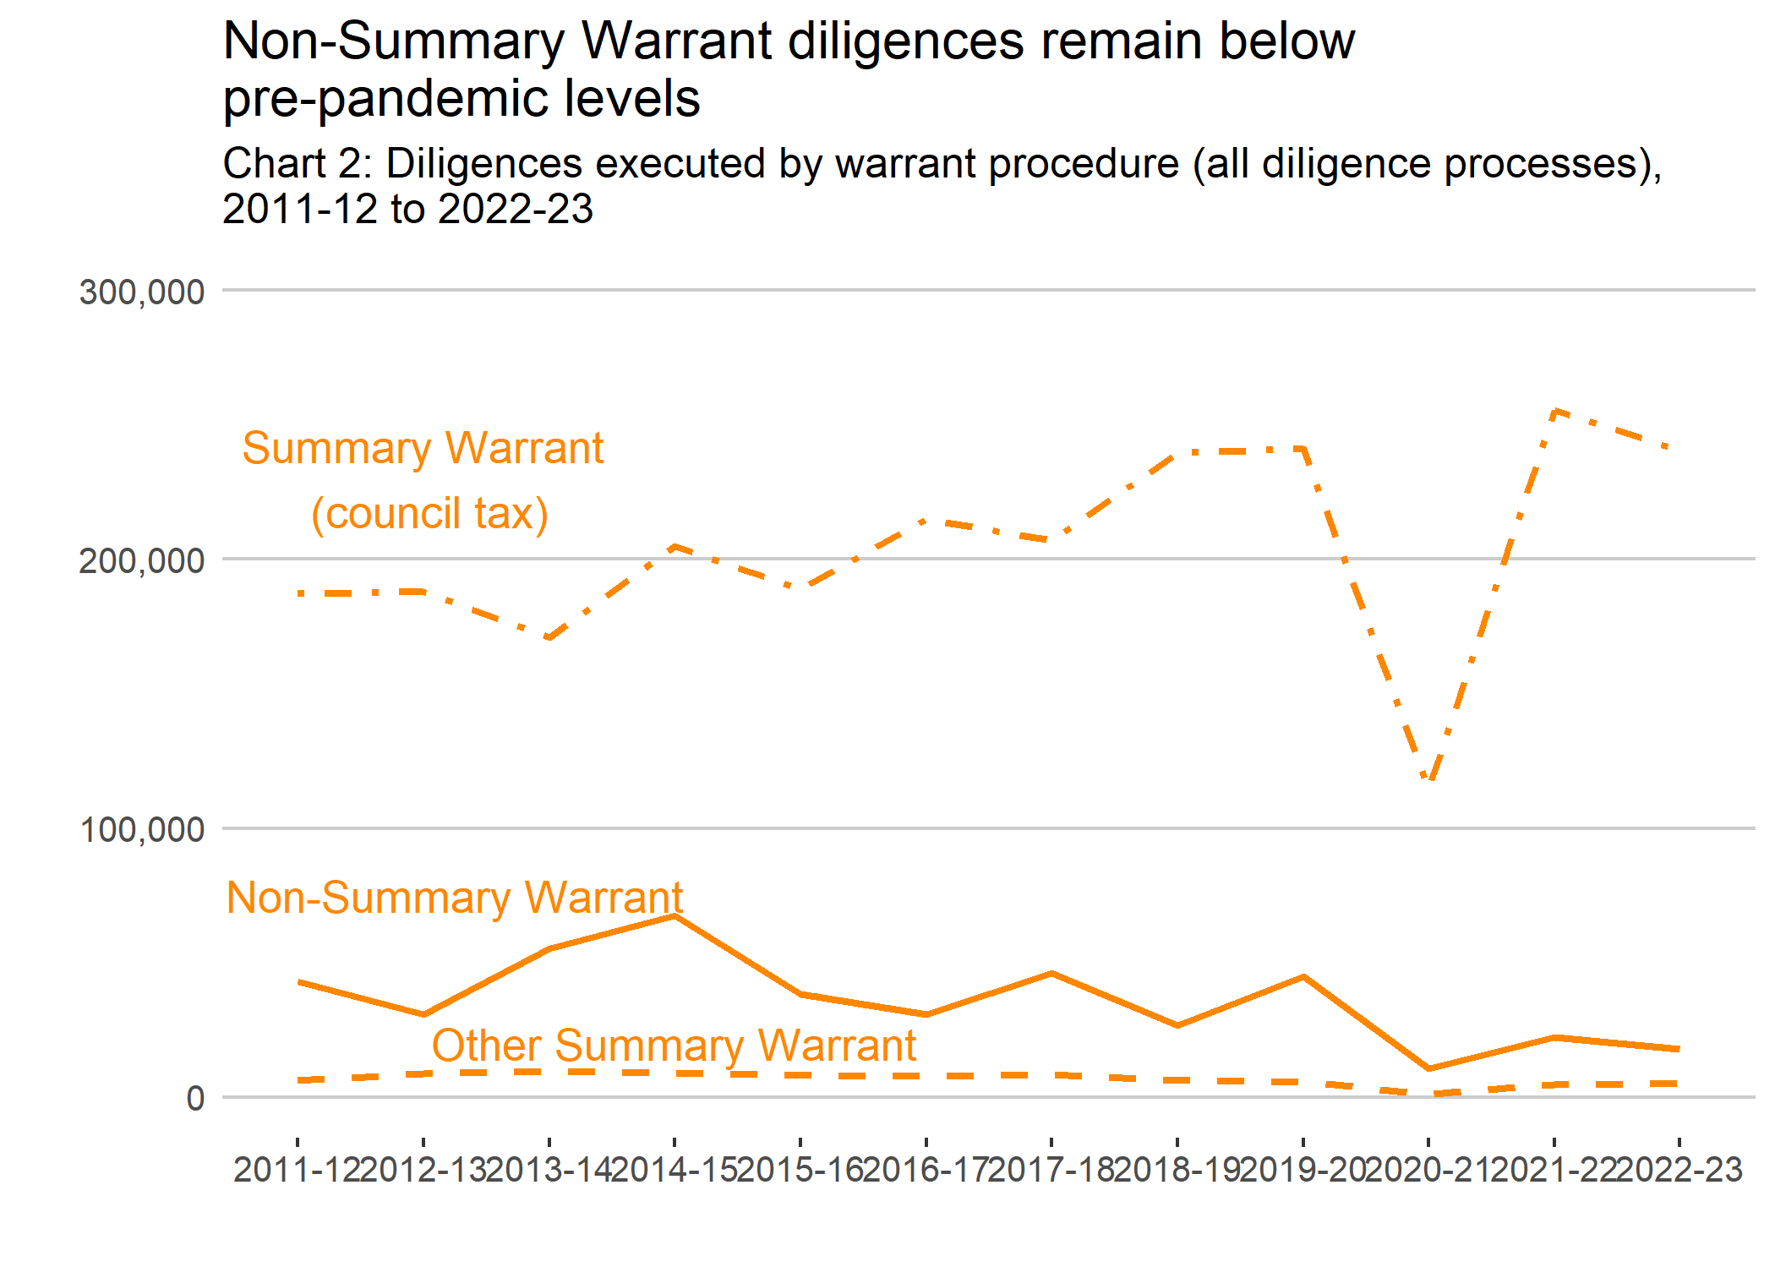
Chart 2 shows the number of diligences executed by warrant procedures between 2011-12 and 2022-23. This chart shows that Non-Summary Warrant diligences remain below pre-pandemic levels.

Diligences executed under Summary Warrant and by diligence processes
Non-earnings arrestments were the most used process for the Summary Warrant for council tax debts. Together with earnings arrestments, these accounted for almost all diligence processes.
There were 188,305 non-earnings arrestments served under Summary Warrant for council tax debts in 2022-23. This is a 6.6% decrease when compared with the previous year. Of all diligences executed under this warrant procedure, 78.3% were non-earnings arrestments.
Earnings arrestments were the second most used diligence process (21.7%). This has decreased by 2.9% when compared to 2021-22. A very small number of other processes were also used for this warrant procedure, these were attachments.
Chart 3 compares arrestments for Summary Warrant for council tax debts over time. This chart shows non-earnings arrestments remain the most used diligence process since 2011-12.
Other Summary Warrant procedure includes diligences for other central and local government debt. Non-earnings arrestments were again the most used diligence process under Other Summary Warrant. There were 5,150 diligences excuted under Other Summary Warrant. There were 4,360 non-earnings arrestments (84.7%) with the rest being earnings arrestments (12.5%) or attachments (2.8%).
Around 2.0% of total diligences executed were under Other Summary Warrant procedure. Diligences using this procedure have increased by 6.8% when compared to 2021-22. This is mostly due to changes in attachments.

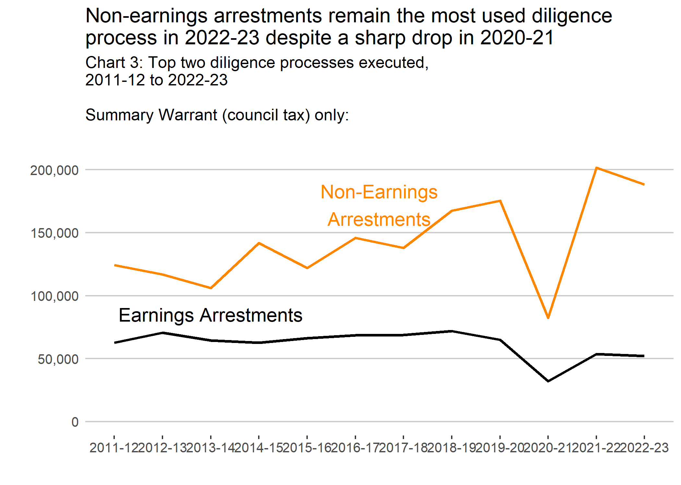
Chart 3 shows the number of diligences executed by diligence process for Summary Warrant (council tax) procedure only between 2011-12 and 2022-23. This chart shows the top two processes only, Non-Earnings Arrestments and Earnings Arrestments. From this chart we see that non-earnings arrestments remain the most used diligence process in 2022-23 despite a sharp fall in 2020-21.

Diligences executed under Non-Summary Warrant by diligence processes
There were 17,930 diligences served under the Non-Summary Warrant procedure. This is 6.8% of total diligences executed in 2022-23.
Chart 4 shows selected diligence processes served under the Non-Summary Warrant procedure. Most diligence processes were non-earnings arrestments (71.8%) or earnings arrestments (25.0%). The remaining diligences in 2022-23 were attachments (2.0%) and other processes (1.3%).
Introduction of Deduction from Earnings Orders mean Current Maintenance Arrestments are rarely used. The Child Support Agency can take child maintenance payments direct from income.
Non-earnings arrestments decreased in 2022-23. This 2022-23 level is still below levels before the COVID-19 pandemic. Non-summary warrant procedure has been subject to changes in recent years. This is due to legislative changes and customer requirements of officers of court.

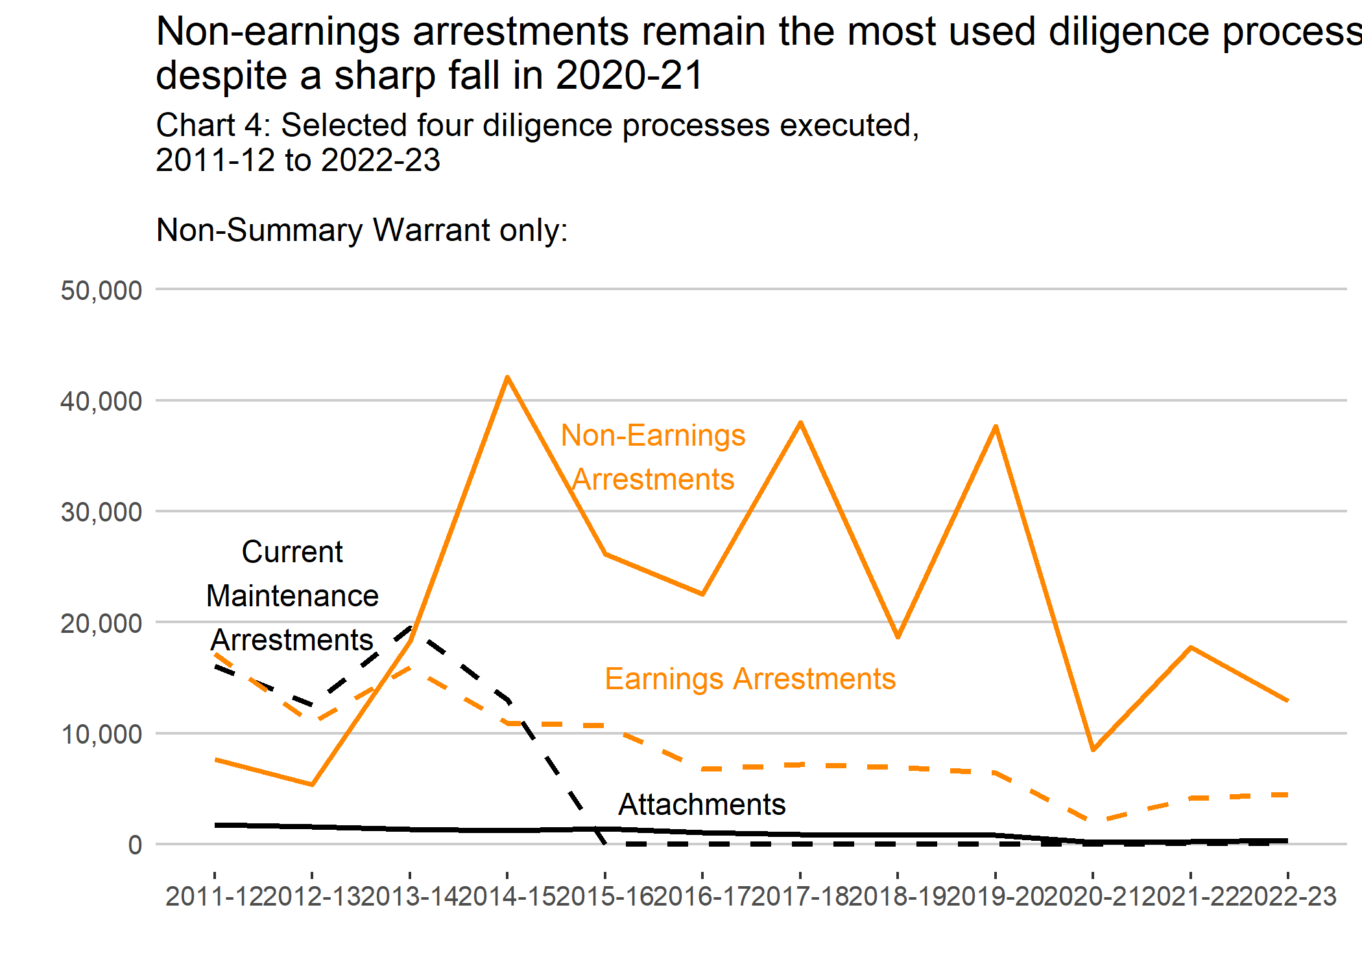
Chart 4 shows the number of diligences executed by diligence process for Non-Summary Warrant procedure only between 2011-12 and 2022-23. This chart shows the following selected processes: Non-Earning Arrestments, Current Maintenance Arrestments, Earning Arrestments and Attachments. From this chart we see that non-earnings arrestments remain the most used diligence process in 2022-23 despite a sharp fall in 2020-21.

Diligences executed by Sheriffdom
In 2022-23, the largest number of diligences executed were in Tayside, Central and Fife, followed by Lothian and Borders.
The number of diligences carried out varied across all six Sheriffdoms.
Decreasing in:
- Grampian, Highlands and Islands (22.1%);
- North Strathclyde (21.3%);
- South Strathclyde, Dumfries and Galloway (18.4%);
- Tayside, Central and Fife (15.1%).
And increasing in: Lothian and Borders (48.8%) and Glasgow and Strathkelvin (1.4%).
Chart 5 shows diligences executed by Sheriffdom for all warrant procedures and diligence processes between 2011-12 and 2022-23. Diligences executed under warrants granted in the Court of Session or other warrant types are not shown.

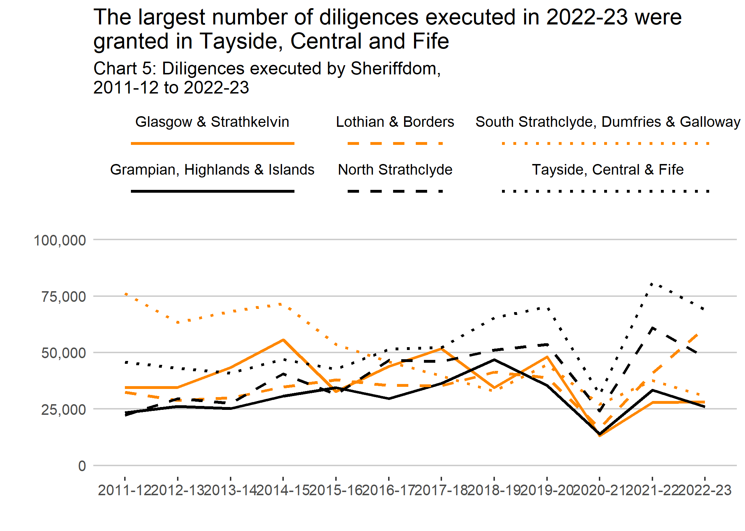
Chart 5 shows the number of diligences executed by Sheriffdom for all warrant procedures and diligence processes between 2011-12 and 2021-22. This chart shows that the largest number of diligences executed in 2022-23 were granted in Tayside, Central and Fife.

Charge for Payment
In 2022-23, there were a total of 270,120 Charge for Payments served, a 2.7% decrease on the previous year.
Chart 6 shows that the majority (79.2%) of Charge for Payments served were under the Summary Warrant procedure in respect of council tax debts. A total of 213,900 Charge for Payments served were under this warrant procedure, a 7.2% decrease when compared with the previous year. This is similar to the number of Charge for Payments served under this warrant procedure in the year prior to the pandemic (2019-20).

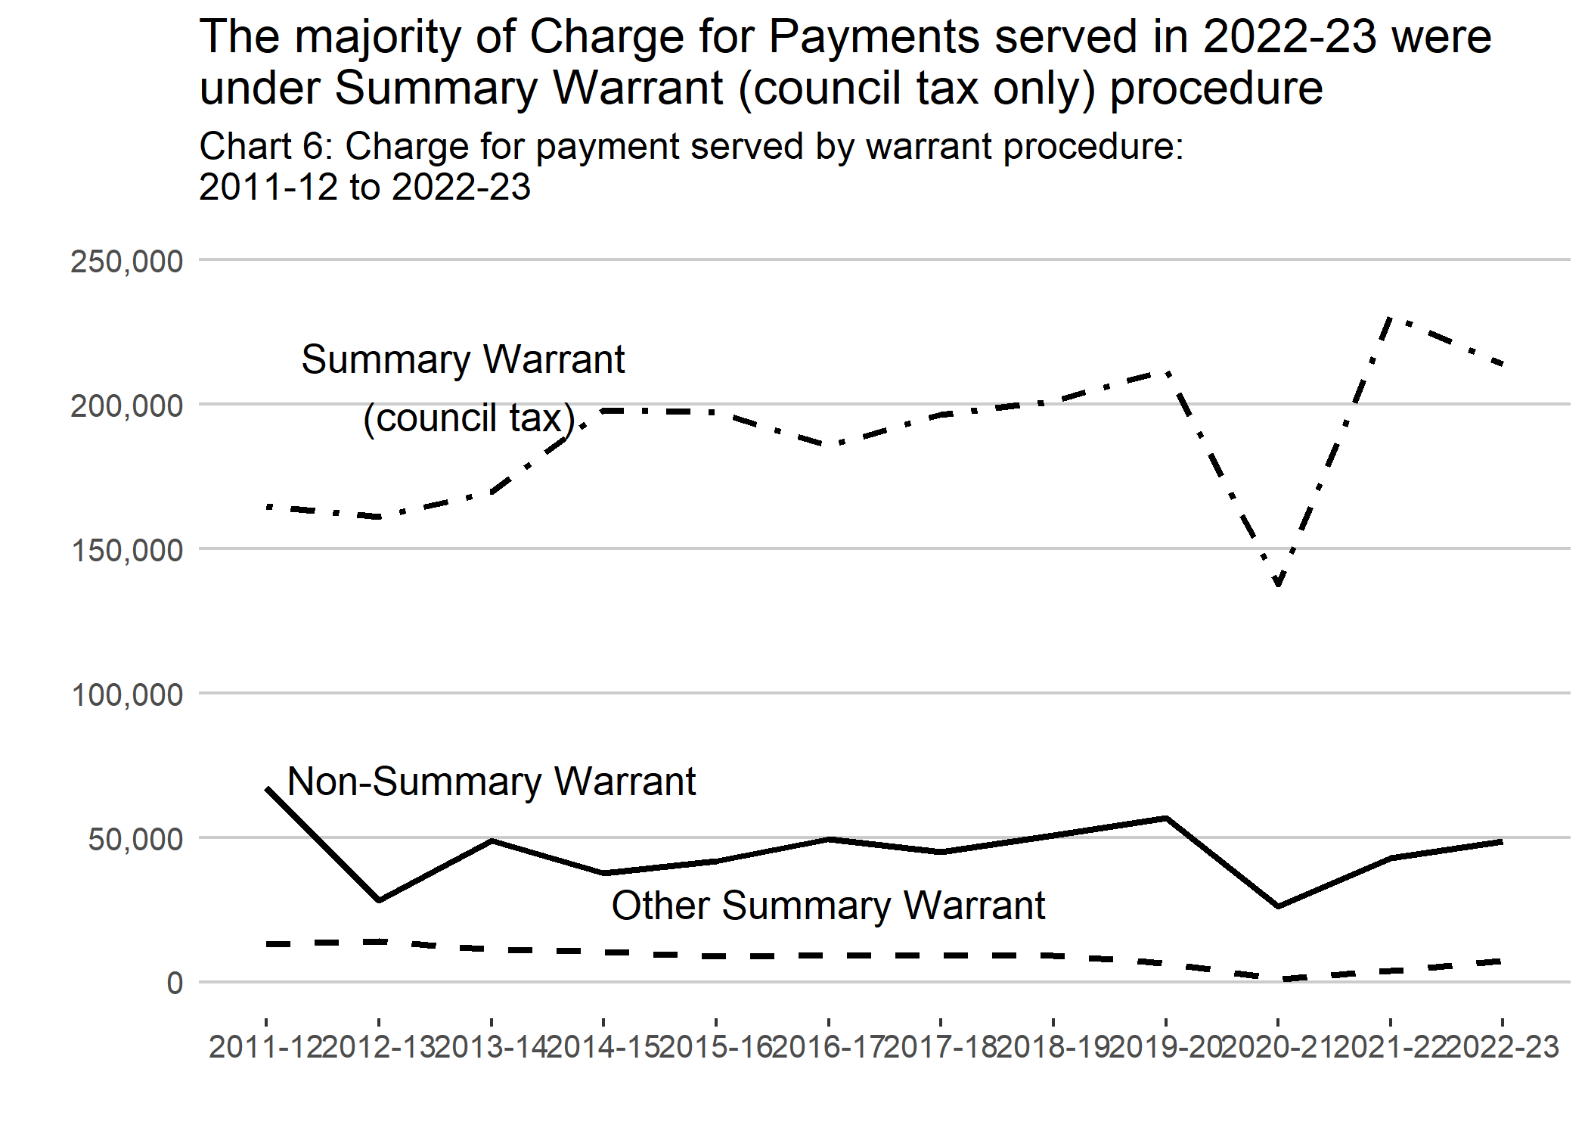
Chart 6 shows the number of Charge for Payments served by warrant procedure between 2011-12 and 2022-23. This chart shows that the majority of Charge for Payments served in 2022-23 were under the Summary Warrant (council tax only) procedure.
The greatest increase in Charge for Payments served were under Other Summary Warrant procedure. There was also an increase under Non-Summary Warrant procedure and a decrease under Summary Warrant (council tax only) procedure.
Further comparisons on Charge for Payments served by warrant procedures are in Table 2 below.
Warrant procedure | 2018-19 | 2019-20 | 2020-21 | 2021-22 | 2022-23 | Annual Change
Summary Warrant (council tax) | 201,025 | 211,760 | 137,780 | 230,560 | 213,900 | -7.2%
Other Summary Warrant | 9,085 | 6,590 | 1,170 | 3,930 | 7,400 | 88.3%
Non-Summary Warrant | 50,725 | 56,730 | 26,085 | 43,055 | 48,820 | 13.4%
Total Charge for Payment Served | 260,835 | 275,080 | 165,035 | 277,545 | 270,120 | -2.7%
Source: Officers of court

Charge for Payment by Sheriffdom
In 2022-23, the largest number of Charge for Payments served were in Tayside, Central and Fife, for all warrant procedures.
Charges for Payment served decreased year-on-year in 2022-23 across five of the six Sheriffdoms (excluding Court of Session and Other). Only one Sheriffdom saw an increase in Charge for Payment served and that was South Strathclyde, Dumfries and Galloway. The largest decrease in Charge for Payments served year-on-year in 2022-23 was in North Strathclyde (13.4% increase) followed by:
- Grampian, Highlands and Islands (6.3%);
- Tayside, Central and Fife (5.3%);
- Glasgow and Strathkelvin (1.6%);
- Lothian and Borders (0.9%).

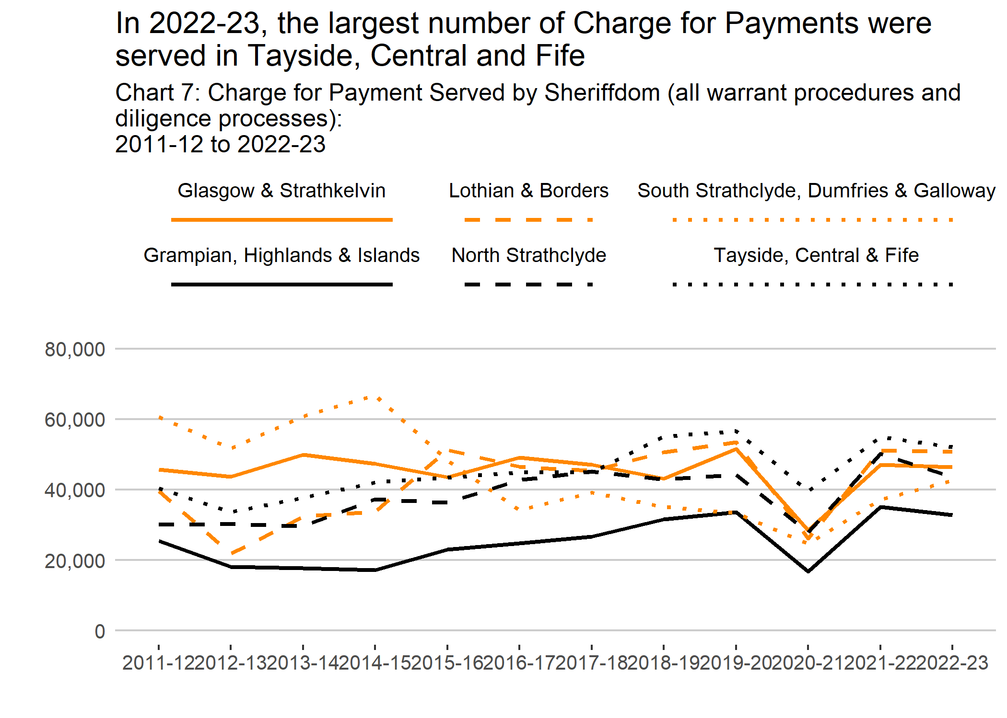
Chart 7 shows the number of Charge for Payments Served by Sheriffdom for all warrant procedures and diligence processes between 2011-12 and 2022-23. This chart shows that in 2022-23 the largest number of Charge for Payments served were served in Tayside, Central and Fife.

Inhibition
Table 3 below shows that Notices of Inhibition increased by 207.1% in 2022-23 when compared with 2021-22. There were 4,585 Schedules of Inhibition in 2022-23, an 81.6% increase on the previous year. Schedules of Inhibition on the Dependence increased by 111.6%.

Nature of action initiated | 2018-19 | 2019-20 | 2020-21 | 2021-22 | Annual Change
Notices of Inhibition | 309 | 220 | 95 | 84 | -11.6%
Schedules of Inhibition | 2,828 | 2,663 | 2,151 | 2,525 | 17.4%
Schedules of Inhibition on the Dependence | 180 | 187 | 105 | 112 | 6.7%
Source: Registers of Scotland

Note that an inhibition does not provide a direct means of debt recovery. However, it does prohibit a debtor from dealing with their heritable property after the inhibition takes effect, providing a safeguard to prevent the disposal of the assets. If an inhibition is registered against a debtor, they will not have the right to sell the property or to take out a secured loan (such as a second mortgage) against it.

Guide to diligence processes

What is diligence?
Diligence is the term for various processes of debt enforcement in Scottish law.
A person or organisation (the creditor) can use diligence if someone who owes them money (the debtor) has failed to pay a sum due. The creditor must have a decree (court order) enforceable in Scotland or a document of debt such as a Summary Warrant before they can carry out diligence.
The court order gives the creditor authority to recover money due to them. They may use any method of legal debt enforcement they choose. In most cases, the creditor must also serve a Charge for Payment (a formal demand for payment) and issue a Debt Advice and Information Package (providing information for debtors to help them deal with their creditors) before using diligence.

Summary Warrant procedure
Summary Warrant is a procedure for central and local government to recover unpaid taxes, duties and other levies. It is used mostly by local authorities and HM Revenue and Customs (HMRC). The process involves an application to court. No hearing is held, but statutory notices are provided to the debtor before application.
For the Summary Warrant, the returns split into two categories:
- warrants raised for the pursuit of payment of council tax
- all other Summary Warrant debt.
Diligence processes served under Summary Warrant procedure include:
- Attachment
- Exceptional Attachment
- Money Attachment
- Earnings Arrestment
- Non-Earnings Arrestment

Non-Summary Warrant procedure
Non-Summary Warrant procedure includes diligences for all other types of debt. It includes consumer debt such as personal loans or credit card debt.
Diligence processes served under Summary Warrant procedure include:
- Attachment
- Exceptional Attachment
- Money Attachment
- Interim Attachment
- Earnings Arrestment
- Non-Earnings Arrestment
- Current Maintenance Arrestments
- Diligence on the Dependence

Community Charge
Since 1 February 2015, local authorities can no longer collect Community Charge debts. Diligences executed for these debts before this date are included under ‘Summary Warrant (council tax)’.

Attachment
Attachment allows a creditor to seize a debtor’s moveable property to recover money owed. Unlike arrestment, used against property held by a third party, attachment can be used to seize property owned by the debtor and in their possession. Attachment cannot be used to seize goods in the debtor’s dwellinghouse, unless an order for exceptional attachment has been granted by the Sheriff.

Diligence on the dependence
Diligence on the dependence is a provisional measure which can be used to secure funds, goods or property. This is to prevent the debtor from disposing of them whilst the action is ongoing. A creditor may apply to the court for authority to carry out arrestment or inhibition on the dependence of the action. This can happen at any time while a court action is ongoing. Diligence on the dependence is not available for Summary Warrant actions.

Earnings arrestment
Earnings arrestment allows a deduction from a debtor’s earnings for enforcement of a single debt. A creditor must be in possession of a decree (or relevant document of debt) and must have issued the debtor with a Charge for Payment. This Charge for Payment must have expired, before proceeding with diligence against earnings. But where the debt is being pursued by a Fines Enforcement Officer for an unpaid court fine, no Charge for Payment is necessary. Where the debtor is an individual, creditors, including Fines Enforcement Officers, must also have provided a Debt Advice and Information Package.

Non-earnings arrestment
Used on a debtor’s moveable assets which are in the hands of a third party. If the assets were in the debtor’s own hands the diligence of attachment would need to be used. Although it is not only used against money held in banks or building societies this is by far the main type of action for this type of arrestment. A creditor could arrest goods that were held in storage by a third party (e.g. furniture).

Exceptional attachment
There is a special procedure for the attachment of non-essential articles kept in a dwellinghouse. The procedure, known as exceptional attachment, can only be used in exceptional circumstances.
An exceptional attachment order authorises the attachment, removal and auction of non-essential assets belonging to the debtor and kept in a dwellinghouse. Before granting an order, the sheriff will take some matters into consideration including:
- the nature of the debt
- whether the debtor resides in the dwellinghouse
- whether they have had money advice
- whether there is, or has been, any agreement between the debtor and creditor for the payment of the debt.

Interim attachment
Interim attachment is a provisional diligence. It protects the interests of creditors during a court action. It restricts the debtor from dealing with attached moveable assets in their possession. It does not allow the creditor to remove or sell the attached items. Following interim attachment, the court may enable action to secure the attached articles.

Money attachment
Money attachment allows a creditor to attach money held on a debtor’s premises. This includes cash including foreign currency, postal orders and banking instruments. It does not apply to money in a dwellinghouse.

Sheriffdom
There are 39 Sheriff Courts in Scotland which cover a particular Sheriff Court district. These districts are separated into six Sheriffdoms each comprising the various courts in its area.
The 6 Sheriffdoms in Scotland are:
- Glasgow and Strathkelvin
- Grampian, Highlands and Islands
- Lothian and Borders
- North Strathclyde
- South Strathclyde, Dumfries and Galloway
- Tayside, Central and Fife.
The information provided by the officers of court allows the information to be reported on by Sheriffdom based on where the warrant was granted. Further information on Sheriffdoms is available from the Scottish Courts and Tribunals Service.

Charge for Payment
For most diligences, the creditor must serve the debtor with a Charge for Payment before a debt can be recovered. It is a formal demand for payment of the amount owed to the creditor including any interest and associated costs. Generally, it gives the debtor 14 days to make payment. If the debtor does not pay the debt within the period specified, the creditor may then use diligence to recover what is owed.
It is necessary to serve a Charge for Payment in most cases before diligence is carried out under any warrant procedure. However, it is possible that multiple years of debts owed (for example, council tax arrears) may be included within one Charge for Payment.
Several different diligences can then be pursued afterwards. Therefore, one Charge for Payment may lead to at least one diligence process being executed afterwards.

Inhibition
Inhibition is a personal diligence against the defender. This prevents the defender from selling, transferring or otherwise disposing of their property. It also prohibits the defender from securing any new loans against the property.
Inhibition can be used when an action for the payment of debt is under consideration by the court, but a decree is not yet granted. This action secures the debtor’s property pending the outcome of the court action. It is a form of diligence on the dependence.
A creditor must have a decree (or relevant document of debt) before proceeding with inhibition. A Schedule of Inhibition must be served on the debtor. Where the debtor is an individual and the action is in respect of debt, the creditor must also provide a Debt Advice and Information Package.

Background information

Official Statistics label
These official statistics provide key information on diligence in Scotland. Official statistics are produced by professional, independent statistical staff.
Official statistics are statistics produced by the UK Statistics Authority, government departments (including executive agencies), the Devolved Administrations in Scotland, Wales and Northern Ireland, any other person acting on behalf of the Crown or any other organisation named on an Official Statistics Order.
Official statistics should follow the Code of Practice for Statistics. They should also fall within the scope of the Office for Statistics Regulation (OSR). OSR assesses their compliance against the Code of Practice.
Further information on the standards of official statistics in Scotland is available here

Data Sources, strengths and weaknesses of the data
These statistics are based on the information submitted by officers of court in 2022-23. General data on the use of inhibition is also supplied by Registers of Scotland for 2022-23. They cover the period following the COVID-19 pandemic in Scotland.
Officers of court need to submit diligence information each financial quarter. Information provided includes:
- the number of Charge for Payments served
- the number of diligences executed by warrant type
- the number of diligences executed in each Sheriffdom
The Society of Messenger-at-Arms and Sheriff Officers (SMASO) directory identifies officers of court. In 2022-23, all members submitted data collection returns.
The published statistics are subject to disclosure control. See Section 84 of the Debtors (Scotland) Act 1987 and Code of Practice for Official Statistics for more information.

Relevant legislation
Diligence in Scotland is covered by the following legislation:
- the Debtors (Scotland) Act 1987
- the Debt Arrangement and Attachment (Scotland) Act 2002
- the Bankruptcy and Diligence etc. (Scotland) Act 2007
As of 1 February 2015, local authorities no longer have the ability to collect Community Charge Debts. This is due to The Community Charge Debt (Scotland) Act 2015.

Quality

Relevance
Relevance is the level that statistics meet the current and potential needs of users.
Section 84 of the Debtors (Scotland) Act 1987 requires officers of court to submit diligence returns to AiB. Diligence statistics are based on the returns submitted by officers of court. They include both Summary Warrant and Non-Summary Warrant procedures. This is also broken down by Sheriffdom and type of diligence processes. Sheriffdoms are geographical districts, each comprising the various courts in the area. This is the only available geographical dimension for this analysis.
It is important to note this publication does not include criminal court fines. The Fines Enforcement Officers are responsible for pursuing payment of fines. The Scottish Courts and Tribunals Service collates these statistics. These are available at [SCTS Official Published Statistics]. (https://www.scotcourts.gov.uk/official-statistics)
AiB produces inhibition statistics based on the information supplied by Registers of Scotland.
AiB itself is a key user of AiB’s diligence statistics. These inform policy decision and development, ministerial briefings and answer public enquiries. Outside AiB, users are:
- officers of court
- the insolvency profession
- debt advice agencies
- local authorities
- other government agencies
- the general public
AiB has an online survey asking users for feedback on this statistics release. AiB use this survey to address user feedback and investigate if current statistics meet user needs.

Accuracy
Accuracy is the closeness between an estimated result and the (unknown) true value.
Officers of court need to submit diligence information each financial quarter. Information provided includes:
- the number of Charge for Payments served
- the number of diligences executed by warrant type
- the number of diligences executed in each Sheriffdom.
The Society of Messenger-at-Arms and Sheriff Officers (SMASO) directory identifies officers of court. In 2022-23, all members submitted data collection returns.
Data validation processes are in place to identify and resolve erroneous data inputs. These may occur when collecting data from officers of court. The processes ensure the accuracy and consistency of statistics within and between tables.

Timeliness and punctuality
Timeliness refers to the time gap between the publication date and the reference period for the statistics.
Punctuality is the time lag between the actual and planned dates of publication for the statistics.
Scottish Diligence Statistics were published every December. This was following the end of the financial year reported. It meant there were around a nine month gap between the end of the financial year and publication of statistics.
It is important that Official Statistics are released on a timely basis that meet the needs of users where practical. The time lag has reduced from nine months to approximately six months. There is an ongoing work programme to assess and improve the diligence statistics.
The exact publication date is pre-announced through a 12-month release calendar. This gives a specific release date at least four weeks in advance where practical – Official statistics: forthcoming publications - gov.scot

Accessibility and clarity
Accessibility is the ease with which users can access the statistics and data. It is also about the format data is available in and the availability of supporting information.
Clarity refers to the quality and sufficiency of the commentary. This includes illustrations, accompanying advice and technical details.
Scottish Diligence Statistics are available free of charge on the AiB website. They are published as HTML and a Word document via the website and ScotStat. The accompanying tables are also published in the Excel format. We aim to make our publications and accompanying tables as accessible as possible. If there are users who wish to receive our publication in a specific format, please contact us. Contact details are at the beginning of our publication report.
It is important to ensure that statistics are presented in a clear, unambiguous way that supports and promotes use by all types of users. To this end, we have adopted the use of plain language as much as possible. The main findings are presented using a series of text and charts. Technical terms, acronyms and definitions are defined and explained when this is appropriate. These approaches would ensure that the statistics can be used effectively.
AiB does want readers and users’ feedback on any aspect of these statistics and encourage them to complete our online survey or get in touch with us. Contact details and link to the online survey are at the beginning of our publication report.

Comparability
Comparability is the degree to which statistics can be compared over time, region or another domain.
Diligence statistics can be compared between:
- different type of diligence processes
- type of warrant procedures
- Sheriffdom.
They can be used to identify trends over time since the financial year 2011-12.
Changes in legislation and policy may affect the extent to which comparisons can be made over time for individual data series. Such change might cause breaks in time series so that statistics from before and after the change are not comparable. Where these are known, they have been highlighted in the commentary and in the general background notes along with the implications for use made clear.

Coherence
Coherence is the level which the statistical processes that generate two or more outputs use the same concepts and harmonised methods.
Scottish Diligence Statistics are the definitive source of statistics for diligences executed and Charge for Payment served in Scotland. These statistics include all warrant procedures and diligence processes.
The Society of Messenger-at-Arms and Sheriff Officers (SMASO) directory identifies officers of court. They are required to fill in the diligence information record template, which is consistent for all officers of court. This ensures that the data is consistent over time. It also allows that data to be comparable between Sheriffdoms within Scotland.
Due to the operational, policy and legislative changes across the UK, it is not possible to make direct comparisons. Users should be mindful of this caveat when making comparisons with other parts of the UK. The Money Advice Trust published their research on local authority debt collection practices in England and Wales: Money-Advice-Trust-Stop-The-Knock-2019-report-September-2019.pdf

Revision Policy
The figures reported in this publication should be final and should not be revised in future. This is because they are based on the information submitted by officers of court.
Yet sometimes, when quality assuring the data for the latest years, errors in term of data classifications applied to any type of warrant procedures may come to light. In which case we may correct the erroneous data classifications in previous years. Any revisions that occur are marked with ‘r’ and an explanatory note in the relevant table. As is the current policy, revisions made for any other reason will be highlighted.
Before the Scottish Diligence Statistics 2020-21 report, we received late data returns from one officer of court for the financial year 2019-20, and so the 2019-20 figures are now updated. Also, we identified a few minor errors in related to data classifications for 2014-15, 2016-17 and 2017-18. If you wish to know more about the impact of these changes, please contact the AiB Statistics Team.

Useful links - outwith Accountant in Bankruptcy
Please note that when accessing the following links you will leave the Accountant in Bankruptcy website. Accountant in Bankruptcy and its staff are not responsible for content external to this website.
- The Society of Messengers-at-Arms and Sheriff Officers (smaso.org.uk)
- Sheriff Courts (scotcourts.gov.uk)
- SCTS Official Published Statistics (for statistics on criminal court fines)

An Official Statistics publication for Scotland
The figures released today are classed as Official Statistics though these were produced in accordance with professional standards set out in the Code of Practice for Official Statistics; they undergo regular quality assurance reviews to ensure that they meet customer needs.

Correspondence and enquiries
For enquiries about this publication please contact:
AiB Statistics Team, Accountant in Bankruptcy
Email: aib_statistics@aib.gov.uk
For general enquiries about Scottish Government statistics please contact:
Office of the Chief Statistician
Telephone: 0131 244 0442
Email: statistics.enquiries@gov.scot

How to access background or source data
The data collected for this statistical bulletin are available on the AiB Statistics webpages at https://www.aib.gov.uk/about-aib/statistics-data/diligence-statistics

Complaints and suggestions
If you are not satisfied with our service or have any comments or suggestions, please write to:
The Chief Statistician, 2W, St Andrews House, Edinburgh, EH1 3DG
Telephone: (0131) 244 0302
Email: statistics.enquiries@gov.scot
If you would like to be consulted about statistical collections or receive notification of publications, please register your interest at: www.gov.scot/scotstat
Details of forthcoming publications can be found at: https://www.gov.scot/publications/official-statistics-forthcoming-publications/

Crown Copyright
You may use or reuse this information (not including logos) free of charge in any format or medium, under the terms of the Open Government Licence. See: http://www.nationalarchives.gov.uk/doc/open-government-licence/version/3/

