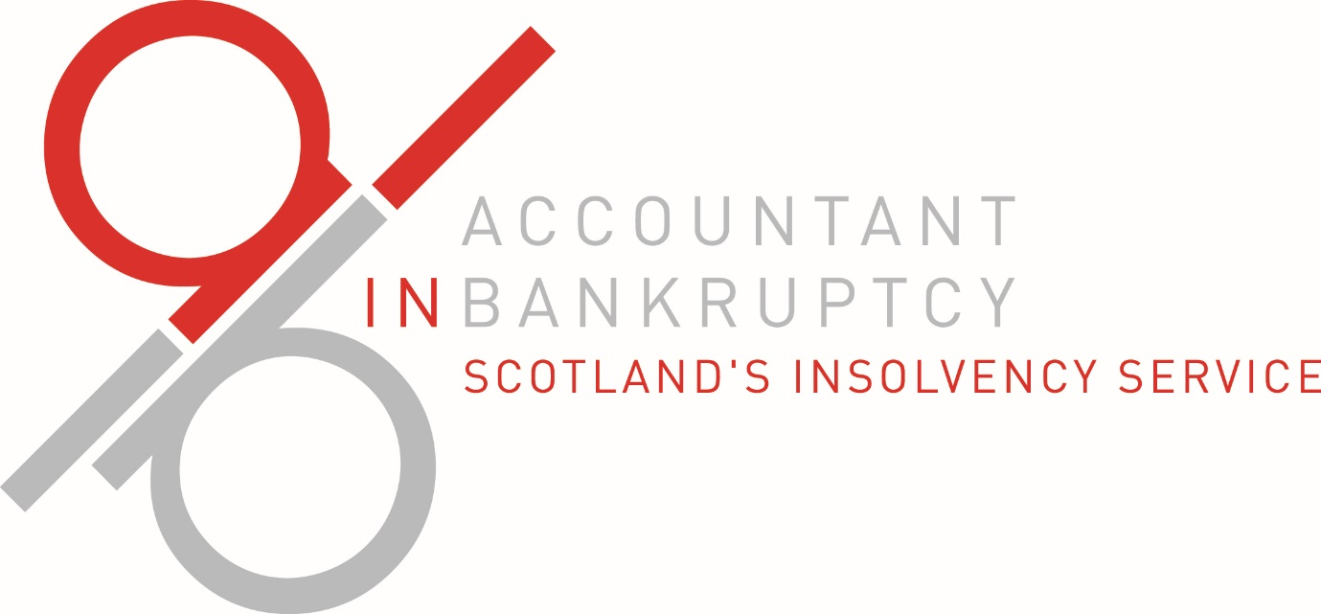
Debtor Application – Part 2

Sensitivity obligation
In terms of the Bankruptcy (Scotland) Act 2016 and Regulations made under that Act certain information about all awarded bankruptcies must generally be included in the Register of Insolvencies (RoI) which is an on-line public record of all insolvencies awarded in Scotland. This information includes a bankrupt person’s name, address and principal place of business(if any).
However, where the Accountant in Bankruptcy is of the opinion that inclusion of the information in the RoI would be likely to jeopardise the safety or welfare of any person, (e.g. where a person may be at risk of violence) information about an awarded bankruptcy need not be included in the RoI.
If you consider that inclusion of information about your bankruptcy (if awarded) in the RoI would be likely to jeopardise your safety or welfare or that of any other person you should set out details below and provide any other supporting evidence (eg from the police) with this form. The Accountant in Bankruptcy will then consider whether information about your bankruptcy (if awarded) should not be included in the RoI.
☐ I confirm that I have a legitimate reason for certain details being withheld or treated sensitively for the purpose of the RoI. (only tick if applicable).
Please give details below

Preferred contact method
Please select your preferred method of contact (you may select more than 1 if you wish)
☐ Phone
☐ Text
☐ E-mail
☐ Writing

Credit/HPI checks
The Accountant in Bankruptcy may carry out these checks in some cases, before award, to verify the level of debt and also confirm if there is any finance agreement valid against your vehicle.
I understand that Accountant in Bankruptcy may carry out credit/HPI checks prior to awarding my bankruptcy and I give my consent to do so.
Signed

Date

Statement of undertakings
I confirm that:
- I have received money advice from the money adviser detailed in the money advice declaration section of this form. I agree to them acting on my behalf throughout the bankruptcy application process.
- I have made a full disclosure of all assets which I owned or in which I had an interest in on my bankruptcy application date.
- I will notify my trustee if I inherit, win or otherwise acquire any further assets during the period of 4 years after my bankruptcy award date.
- I will immediately inform my trustee of any change of address or change in my financial circumstances during the period of 4 years after the date of bankruptcy.
- I understand that I have a legal obligation to co-operate with my trustee and to provide any financial information or documents which may be required.
- I understand that until I am discharged I may not, either alone or jointly with another person, obtain credit (which includes where goods are hired to me under a hire purchase agreement or agreed to be sold to me under a conditional sale agreement) either:
(a) of £2000 or more; or
(b) of any amount, where, at the time of obtaining credit, I have debts amounting to £1000 or more
without informing the person from whom I obtain it of my bankruptcy.
- I understand that, until I am discharged I am subject to certain restrictions on the appointments I may take up or offices I may hold, including that I may not be a member of parliament or a justice of the peace.

- I understand that until I am discharged I may not act as a director of a limited company or be involved directly or indirectly in the promotion, formation or management of a limited company without the leave of the court.
- I understand that after 12 months from my bankruptcy award date (or normally after 6 months for Minimal Asset Process cases) the Accountant in Bankruptcy may discharge me and that my discharge may be dependent on my compliance with this statement of undertakings.
- I understand that I may be required by my trustee to undergo financial education and that my discharge may be dependent on completion of this financial education.
- I understand that any assets which vested in my trustee on my bankruptcy award date, and which have not been sold, realised or ingathered by my trustee, will continue to vest in my trustee notwithstanding my discharge.
- I understand that any assets which were acquired by me during the period of 4 years after my bankruptcy award date and which would have vested in my trustee if they had been part of my estate on my bankruptcy award date will vest in my trustee and that any such assets which have not been sold, realised or ingathered by my trustee, will continue to vest in my trustee notwithstanding my discharge.
- I understand that if my bankruptcy is converted from MAP to Full Administration my discharge may not be granted until a further £110 is paid.
- I understand that my circumstances will be assessed for the purpose of a debtor contribution order and that my discharge may be dependent on compliance with that order.
- I understand that my on-going liabilities, e.g. utility payments, may not be included in the sequestration and I may still have a duty to pay them.

Note for completion – If you are signing as executor, or entitled to be appointed as executor, on the estate of a deceased debtor, undertakings 1, 7, 8, 10, 14 and 15 do not apply. You are giving the remaining undertakings, as appropriate, in relation to the position of the deceased debtor or the deceased debtor’s estate or the position of executor on the estate of the deceased debtor.
Applicant name

Signature

Date

Witness name

Witness signature

Date

Statement of Truth
I,
agree to be made bankrupt, if I meet the bankruptcy criteria as defined in the Bankruptcy (Scotland) Act 2016, and certify that the information I have supplied in this application form is true, complete and accurate to the best of my knowledge and belief.
I understand that by becoming bankrupt, I may be required to make regular contributions from my income if I am financially able to do so and that my assets may be sold to repay my debts.
I have read and understood the warning below.
Note for completion – If you are signing as executor, or entitled to be appointed as executor, on the estate of a deceased debtor, you are agreeing and certifying in relation to the estate of the deceased debtor being made bankrupt. In relation to the warning below, the reference to bankruptcy restrictions does not apply.
Signature

Date

Warning
It is a criminal offence under section 8(4) or 218(1) and (2) of the Bankruptcy (Scotland) Act 2016 for you to make a false statement in this form in relation to your assets or business or financial affairs, to not disclose any material fact in this statement or make a material misstatement unless you can show that you did not know that statement was false and had no reason to believe it was false.
On summary conviction, you may be liable to a fine of up to £5,000 or to imprisonment for a maximum period of three months or to both.
If you deliberately do not disclose all relevant information or if you deliberately make a false statement when completing this form, you may become subject to bankruptcy restrictions.

Payment information
An application fee of £150 may be payable for a Full Administration case where you have been assessed by the Common Financial Tool as requiring to make a debtor contribution (*no fee is payable if you are in receipt of a Qualifying Benefit, please confirm this with your money adviser *). There is no fee payable if you are applying under the Minimal Asset Process (MAP).
There is an option to complete this application online which is a quicker, more efficient process. This must be carried out by your money adviser. The payment method options are listed below. Payments can be made online if following the online application method. If one of the other payment methods is chosen then payment should be made following the submission of your online application and must be received by AiB before the application can be processed. If you are using a paper application form then payment should be made along with or (if applicable) prior to the submission of your form.

Payment methods:

Online
using your debit card following the submission of your application (only possible for online applications).

Directly into a Royal Bank of Scotland branch
either in full or in instalments. You must do so over the counter in order to obtain a full bank receipt(s). DO NOT use the quick deposit process as we may not be able to match your fee with your application. Payment should be made into the following account.
Sort code – 830608 Account number – 11 44 46 55
If applying online you may either scan your receipt(s) onto the system to submit them electronically or alternatively post them to the address below quoting your case reference number from your online application on the back of the receipt(s) along with your name and address so that we can match your payment to your application.
Once your receipt(s) have been received your application will be moved forward for processing. If using a paper application your receipt(s) should be included with your form with your name and address on the reverse of the receipt(s).
AiB – Debtor Application Payments
1 Pennyburn Road
Kilwinning
KA13 6SA

By cheque
If applying online, post your cheque into AiB’s office at the address above quoting your case reference number from your online application on the back of the cheque along with your name and address so that we can match your payment to your application. Once your cheque has been received your application will be moved forward for processing. If using a paper application your receipt(s) should be included with your form.

In person at the AiB office
paying in cash or by card at the reception desk at the Accountant in Bankruptcy. If applying online, this will automatically move your application on for processing. If using a paper application the payment should accompany your form.
We will not accept payment by credit card.
Full payment is required before any application is processed.

Payment verification
Please verify the appropriate payment method used and give the payment reference number below.
I have paid using the following method:
☐ At my local RBS branch (you must submit proof of payment/receipt)
☐ Cheque (enclosed with this form)
☐ In person at the AiB office (must provide payment reference number below)
☐ Paid on-line
Payment reference number

Signature

Date

Check List
This check list has been designed to ensure that you have completed all relevant sections of the application form.
I confirm that I have:
☐ Completed all sections relevant to me
☐ Signed and dated the Statement of Truth in Part 2 of this form
☐ I have supplied my Money Adviser with all relevant documentation relating to my income, expenses, policies and assets
☐ I have signed and dated the payment verification statement
☐ I have included my payment reference number on this form
☐ I have consented to AiB carrying out automatic credit/HPI checks in Part 2 of this form

FORM 2
CERTIFICATE FOR SEQUESTRATION
Bankruptcy (Scotland) Act 2016
Section 9
This certificate is invalid unless –
Completed by an authorised person defined in section 4(2) of the Bankruptcy (Scotland) Act 2016, and countersigned by the debtor.
This certificate is valid for 30 days including the date signed by the authorised person.
Insert money adviser’s name

Job title

Organisation

Address

Town

Postcode

E-mail address

Phone number

confirm that, under sections 4(2) and 9(1) of the Bankruptcy (Scotland) Act 2016, I am authorised to sign this certificate which has been applied for by the debtor, and certified that, on the basis of the information provided to me, by
Insert debtor’s name and title

Address

Town

Postcode

Telephone number

Date of birth

Is unable to pay their debts as they become due.
I have provided the debtor with a copy of the Debt Advice and Information Pack and, where appropriate, have advised the debtor of the options of a voluntary repayment plan, a debt payment programme under the Debt Arrangement Scheme or Trust Deed.
I have advised the debtor that an award of sequestration, if granted, is recorded in a public register and may result in one or more of the following:
- the debtor being refused credit, or being offered credit at a higher rate, whether before or after the date of the debtor being discharged;
- the debtor not being able to remain in his/her current place of residence;
- the debtor being required to relinquish property which they own;
- the debtor being required to make contributions from income for the benefit of creditors;
- damage to the debtor’s business interests and employment prospects;
- the debtor still being liable for some debts which are excluded;
- the debtor’s past financial transactions being investigated; and
- other restrictions or requirements imposed on the debtor as a result of the debtor’s own circumstances and actions.
Please select the relevant qualification which grants you the authority to provide a certificate for sequestration.
☐ person qualified to act as insolvency practitioner in relation to individuals in accordance with section 390 of the Insolvency Act 1986 (c.45)
☐ person who works for such an insolvency practitioner, and who has been given authority by that insolvency practitioner to act on behalf of that insolvency practitioner in providing money advice.
☐ person who works as money adviser for organisations which have been awarded accreditation at type 2 level or above against the Scottish National Standards for Information and Advice Provision
☐ person approved for the purpose of the Debt Arrangement Scheme
☐ person who works as a money adviser for citizens advice bureau which is a full member of the Scottish Association of Citizens Advice Bureaux/Citizens Advice Scotland
☐ person who works as money adviser for a local authority in Scotland
Authorised person signature

Date

Debtor’s name

confirm that I have provided the authorised person with correct and complete information about my financial circumstances.
Debtor’s signature

Date

Form 12

Form of Undertaking to act as Trustee in Sequestration
on the Application of a Debtor
Bankruptcy (Scotland) Act 2016
Section 51(8) and (9)
This form should be completed by a qualified Insolvency Practitioner if:
- a debtor applies for an award of sequestration under section 2, 5 or 6 of the Bankruptcy (Scotland) Act 2016,
- the debtor nominated the Insolvency Practitioner to act as the trustee in the sequestration, and
- the Insolvency Practitioner undertakes to so act.

Undertaking
I, (Insert Insolvency Practitioner’s name)

Insert business address

Town

County

Postcode

hold the necessary authorisation to act as an insolvency practitioner under Part 13 (insolvency practitioners and their qualification) of the Insolvency Act 1986 to enable me to act as a trustee in sequestration under the Bankruptcy (Scotland) Act 2016.
Authorising professional body (or other authority)

I undertake, if appointed by the Accountant in Bankruptcy to do so, to act as the trustee in the sequestration of
Insert debtor’s name

Insert debtor’s address

Town

County

Postcode

Signed (insolvency practitioner)

Date

